Teasers
  Knock knock.
  Who’s there?
  Spa.
  Spa who?
  Open space for you to move…ha ha ha
  Advance one space
  Teasers
  You’re thinking too much; give your mind a break. Move forward 2 spaces
  Teasers
  We know it’s getting tough, and you want to win, how about you get a free pass. Instead of answering a Brain freeze question to advance, just answer a question from the easy pile if there’s any left.
  (Hold on to card until it is used)
  Teasers
  We know it’s getting tough, and you want to win, how about you get a free pass. Instead of answering a Brain freeze question to advance, just answer a question from the easy pile if there’s any left.
  (Hold on to card until it is used)
  Teasers
  You’ve gotten a boost in your IQ! Congratulations! Time to party, advance 2 spaces.
  Teasers
  Riddle me this, riddle me that, you think you’re right? Think again. Try a riddle once again.
  Teasers
  Battle the person in front of you for their space. If you win, you take their place and advance a space
  Teasers
  The forces of the riddle masters are with you, they have helped you advance. Switch places with the person right in front of you.
  Teasers
  Once upon a time, there was a riddler walking down the road to victory! You need to get to the finish hurry as fast as you can. Take a riddle from the easy pile, if you guess correct, advance three spaces.
  Teasers
  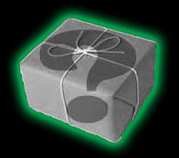
  Teasers
  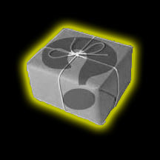
  Teasers
  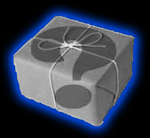
  Teasers
  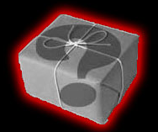
  Teasers
  Teasers
  Teasers
  Teasers
  Teasers
  Teasers
  Knock knock.
  Who’s there?
  Spa.
  Spa who?
  Open space for you to move…ha ha haa
  Advance one space
  Teasers
  Knock knock.
  Who’s there?
  Spa.
  Spa who?
  Open space for you to move…ha ha ha
  Advance two spaces
  Teasers
  We know it’s getting tough, and you want to win, how about you get a free pass. Instead of answering a Brain freeze question to advance, just answer a question from the easy pile if there’s any left.
  (Hold on to card until it is used)
  Teasers
  Teamwork you say, and work together? How about you stick to your game and advance away. Switch places with whomever you wish.
  (only with player on the same question mark as you)
  Teasers
  Reverse order of play
  Teasers
  Teamwork you say, and work together? How about you stick to your game and advance away. Switch places with whomever you wish.
  (only with player on the same question mark as you)
  Teasers
  Can you follow the sequence?
  10. 9. 8. 7. 6. 5. 4. ___
  Yup! Advance 3 spaces!!!
  Teasers
  Reverse order of play
  Teasers
  Roses are red, violets are blue, riddles are sweet and spaces are too.
  Battle with the player across from you to decide who gets to advance with sweetness away.
  Winner advances 2 spaces.
  Teasers
  Teasers
  Teasers
  Teasers
  Teasers
  Teasers
  Teasers
  Teasers
  Teasers
  Teasers
  Reverse order of play
  Teasers
  Not having a good day now are you? Redeem yourself. If you can battle two people and win, you get to advance 3 spaces.
  If not, you loose a turn.
  Teasers
  Reverse order of play
  Teasers
  Can you follow the sequence? Advance the number of spaces indicated by the sequence for the missing number.
  100. 99. 88. 77. 66. 55. 44. ___
  Sike! Advance 3 spaces!!!
  Teasers
  Reverse order of play
  Teasers
  Teamwork you say, and work together? How about you stick to your game and advance away. Switch places with whomever you wish.
  (only with player on the same question mark as you)
  Teasers
  Riddle me this, Riddle me that, what do you think will happen next?
  Battle the person sitting directly to your right. If you win advance two spaces
  Take the chance.
  Teasers
  Not having a good day now are you? Redeem yourself. If you can battle two people and win, you get to advance 3 spaces.
  If not, you lose a turn
  Teasers
  You’ve gotten a boost in your IQ! Congratulations! Time to party, advance 2 spaces.
  Teasers
  Teasers
  Teasers
  Teasers
  Teasers
  Teasers
  Teasers
  Teasers
  Teasers

